Intro to SQL Commands - DML

✅ What is SQL Commands – DML (Data Manipulation Language)?
# Source: AI Source: Provided by: [Data Path: Persons Table -> ID Column: 1, Name_En Column: Motasem Essam] -> From: [ChatGPT] on [6/11/2026]
DML stands for Data Manipulation Language, and it includes SQL commands used to modify or work with data stored inside database tables — not the structure of the tables, just the contents.

🧩 Core DML Commands:
# Source: AI Source: Provided by: [Data Path: Persons Table -> ID Column: 1, Name_En Column: Motasem Essam] -> From: [ChatGPT] on [6/11/2026]
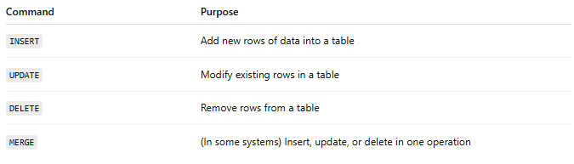
Command | Purpose
INSERT | Add new rows of data into a table
UPDATE | Modify existing rows in a table
DELETE | Remove rows from a table
MERGE | (In some systems) Insert, update, or delete in one operation

📌 Examples:

🔹 INSERT
# Source: AI Source: Provided by: [Data Path: Persons Table -> ID Column: 1, Name_En Column: Motasem Essam] -> From: [ChatGPT] on [6/11/2026]
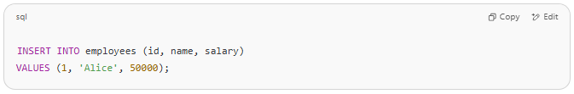
INSERT INTO employees (id, name, salary)
VALUES (1, 'Alice', 50000);

🔹 UPDATE
# Source: AI Source: Provided by: [Data Path: Persons Table -> ID Column: 1, Name_En Column: Motasem Essam] -> From: [ChatGPT] on [6/11/2026]
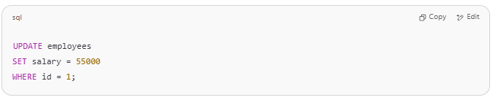
UPDATE employees
SET salary = 55000
WHERE id = 1;

🔹 DELETE
# Source: AI Source: Provided by: [Data Path: Persons Table -> ID Column: 1, Name_En Column: Motasem Essam] -> From: [ChatGPT] on [6/11/2026]
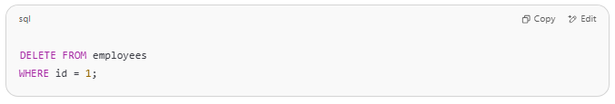
DELETE FROM employees
WHERE id = 1;

📘 Key Notes:
# Source: AI Source: Provided by: [Data Path: Persons Table -> ID Column: 1, Name_En Column: Motasem Essam] -> From: [ChatGPT] on [6/11/2026]
- DML changes data, not structure.
- DML commands are often used with transactions, so changes can be rolled back or committed (related to TCL).
- DML affects the rows in a table.

✅ In your folder system:
# Source: AI Source: Provided by: [Data Path: Persons Table -> ID Column: 1, Name_En Column: Motasem Essam] -> From: [ChatGPT] on [6/11/2026]
📁 SQL Commands – DML is for:
- INSERT, UPDATE, DELETE, and similar operations on data.
Let me know if you want a DML practice sheet or visual examples!

